Name: Yuvaraj Bharath .S

Emp_Id:11998

Semester result Processing System

In this project i have implemented the semester results to provide to students and teacher can add marks to the students based on faculty handling the batches and admin can add new student's ,faculty and courses. Admin major role is to create an username and password by admin and sent through email by the concept of JWT Role based authentication and smttp.email is the namespace used in ASP.NET Web Api and view the results and download the results sheets by the student .

First I start with frontend I use the React js for frontend with the UI Library called “Chakra UI” . It is the react component library for making rich UI’s like tailwind css.

Frontend:

Login page :

I have create an login page for both student and faculty and i based on their roles it navigate through respective pages . This the student login page

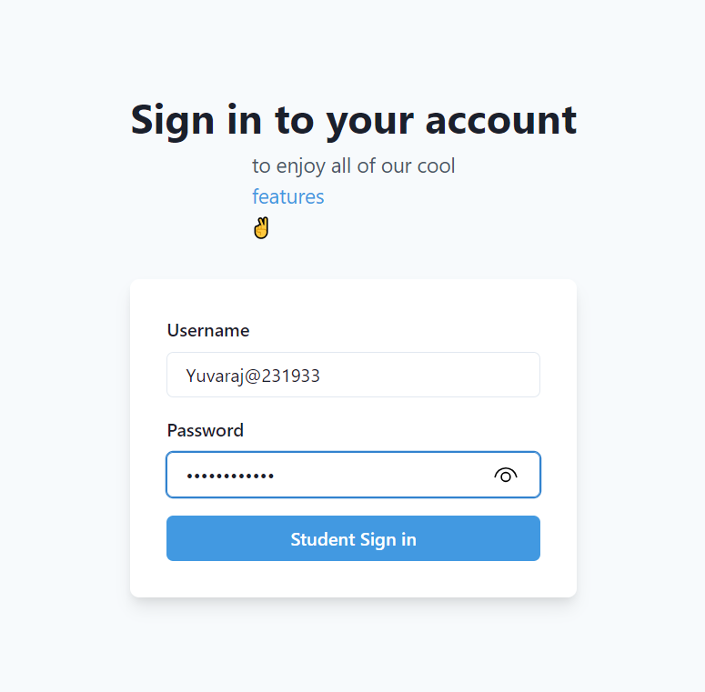

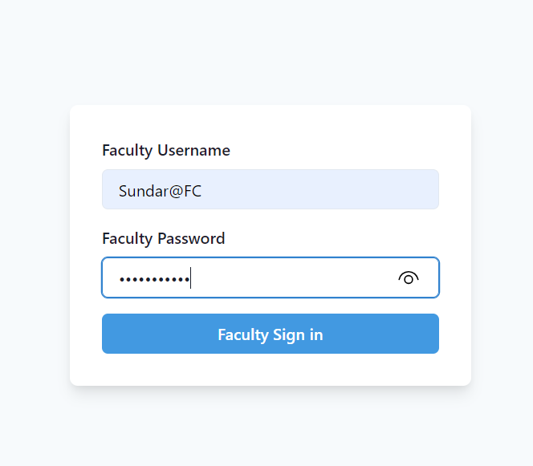

After i sign in with this credentials it will navigate through respective pages ,

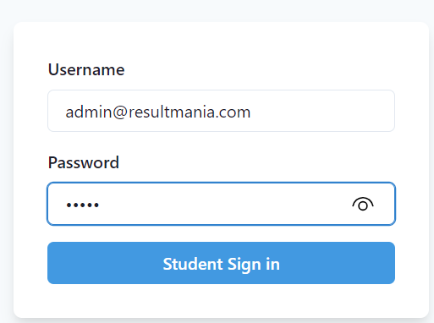

This login credientials for admin.

Student Dashboard page:

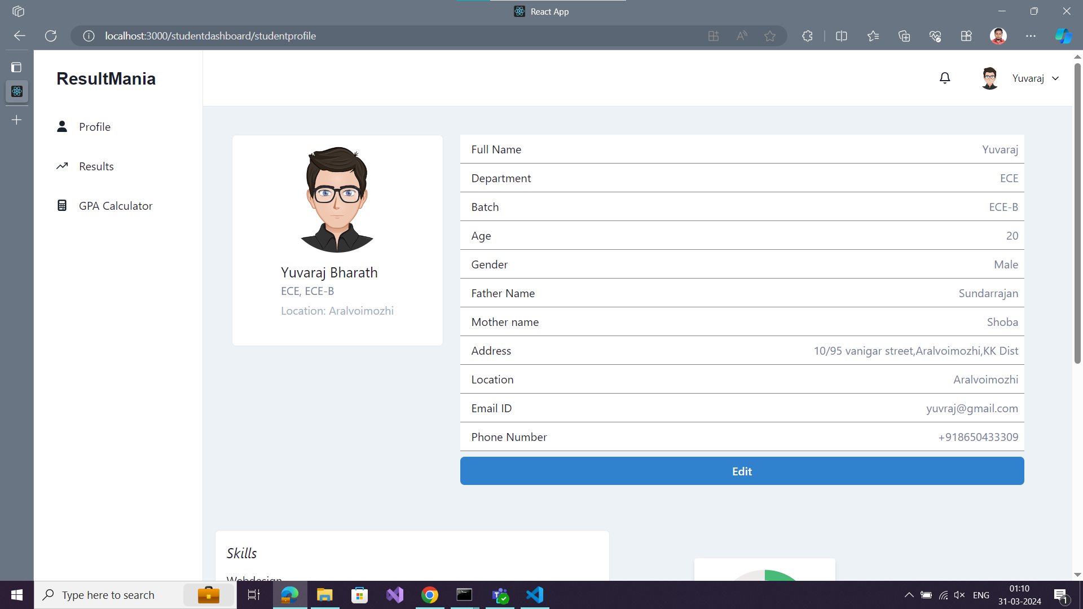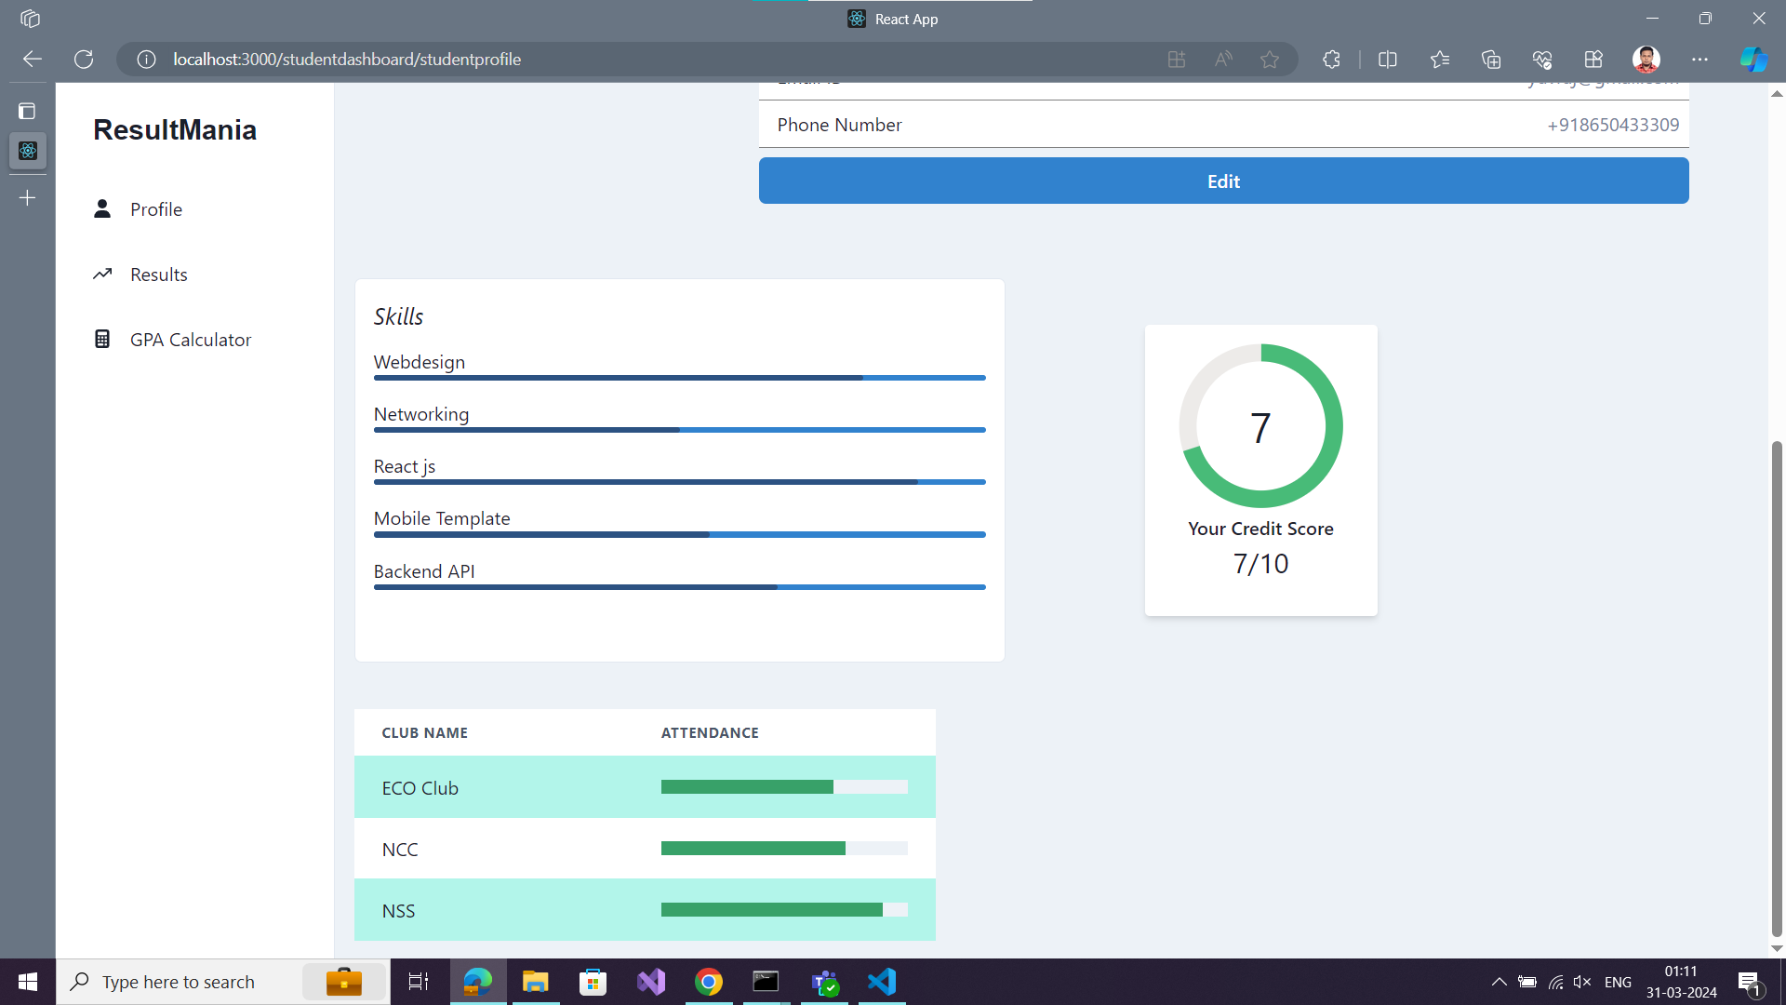 these are profile pages.

View result page:

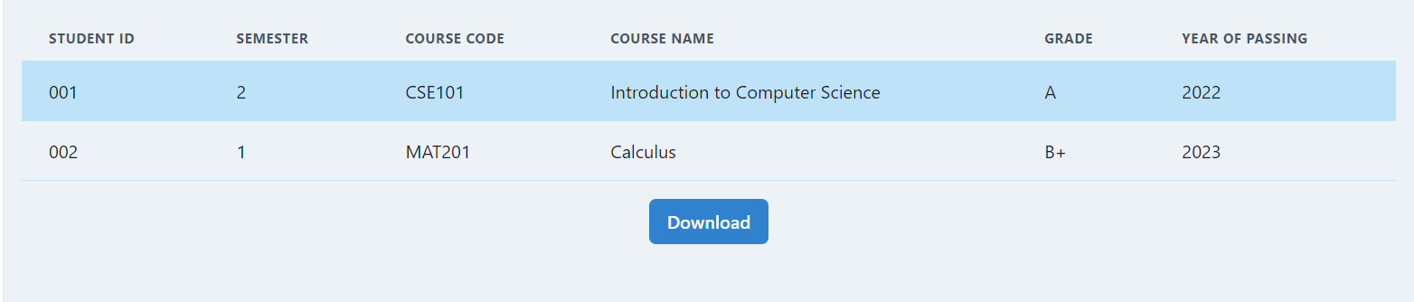

This page i add the download page and save it in pdf format.

GPA Calculator :

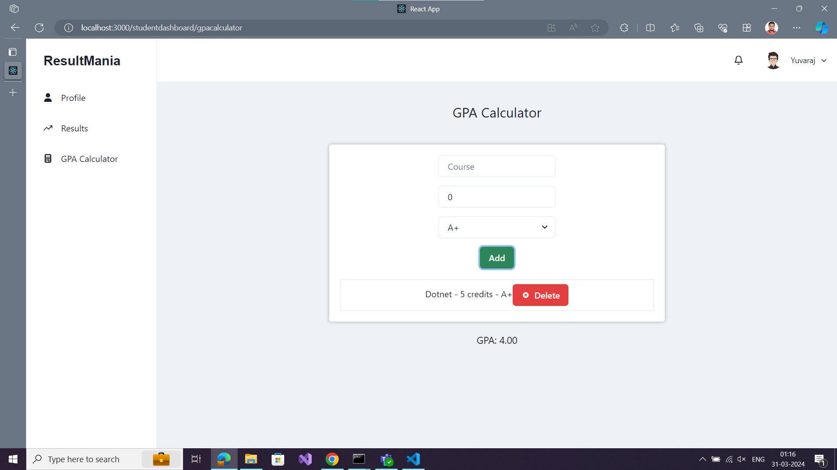

Teacher dashboard:

Teacher profile:

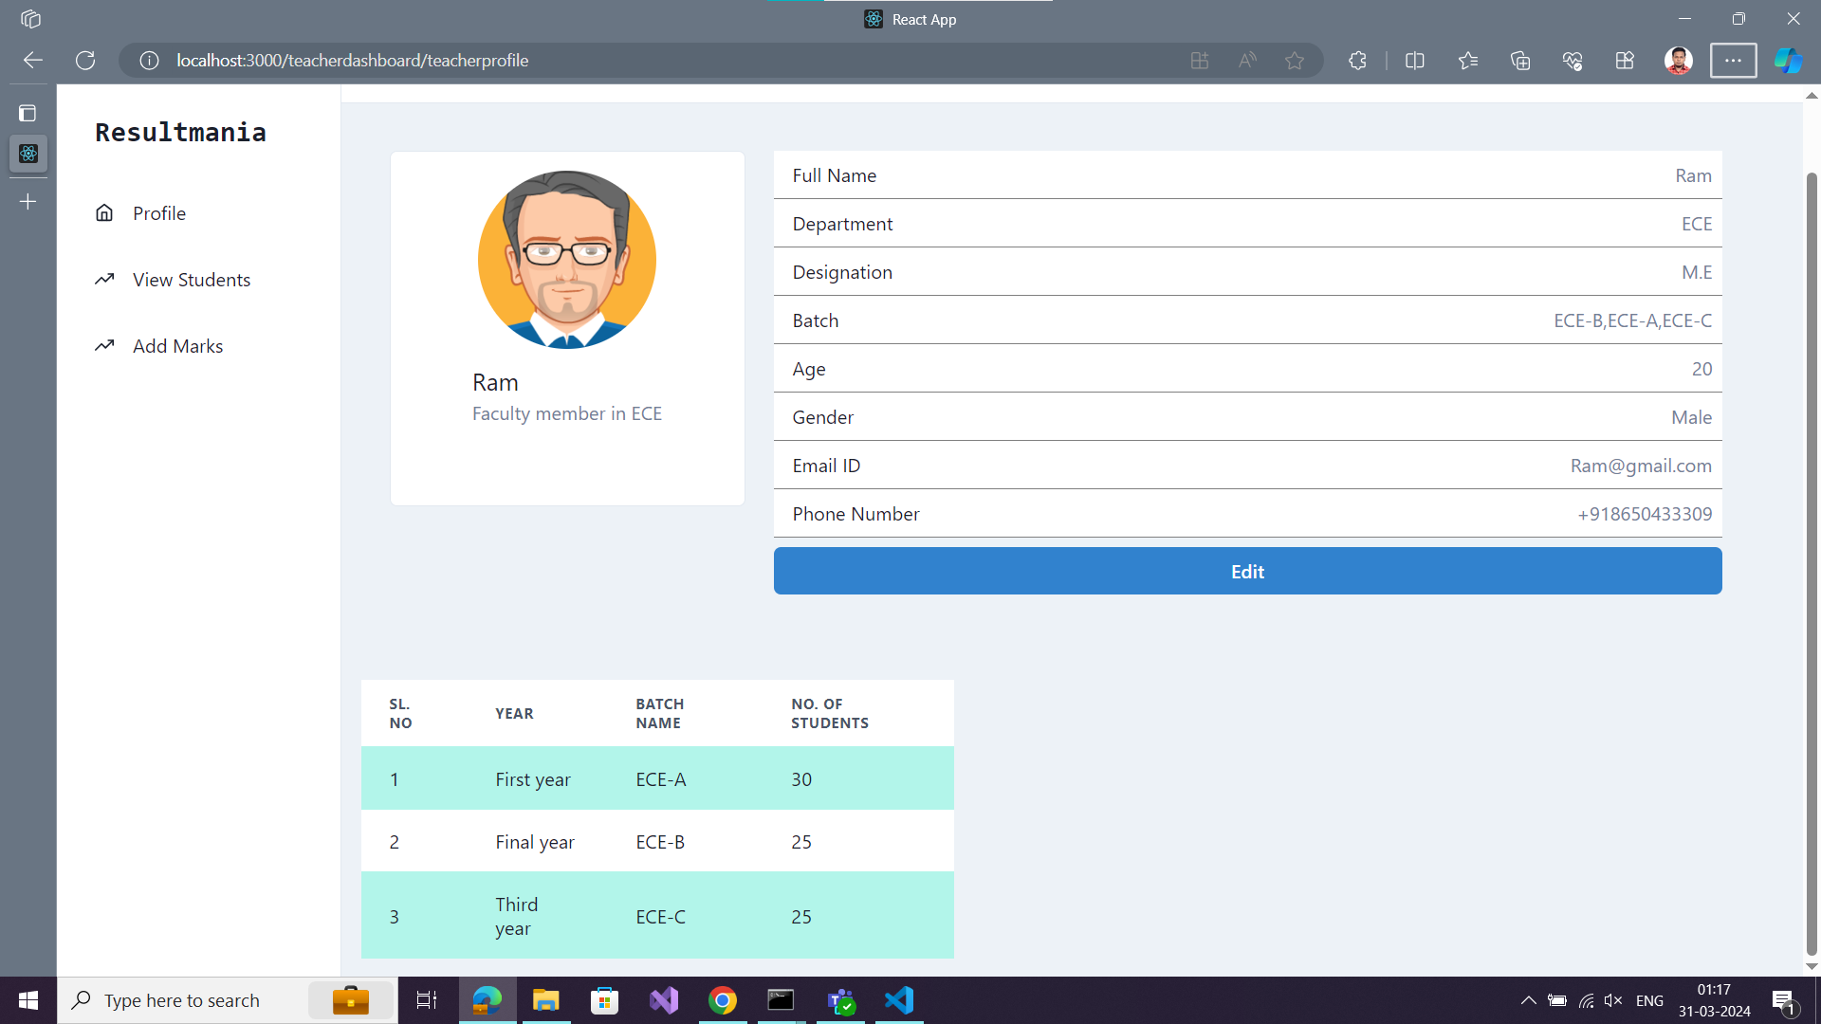

View students :

Teacher can view the list of students based on the teacher can handle the batches of the colleges.

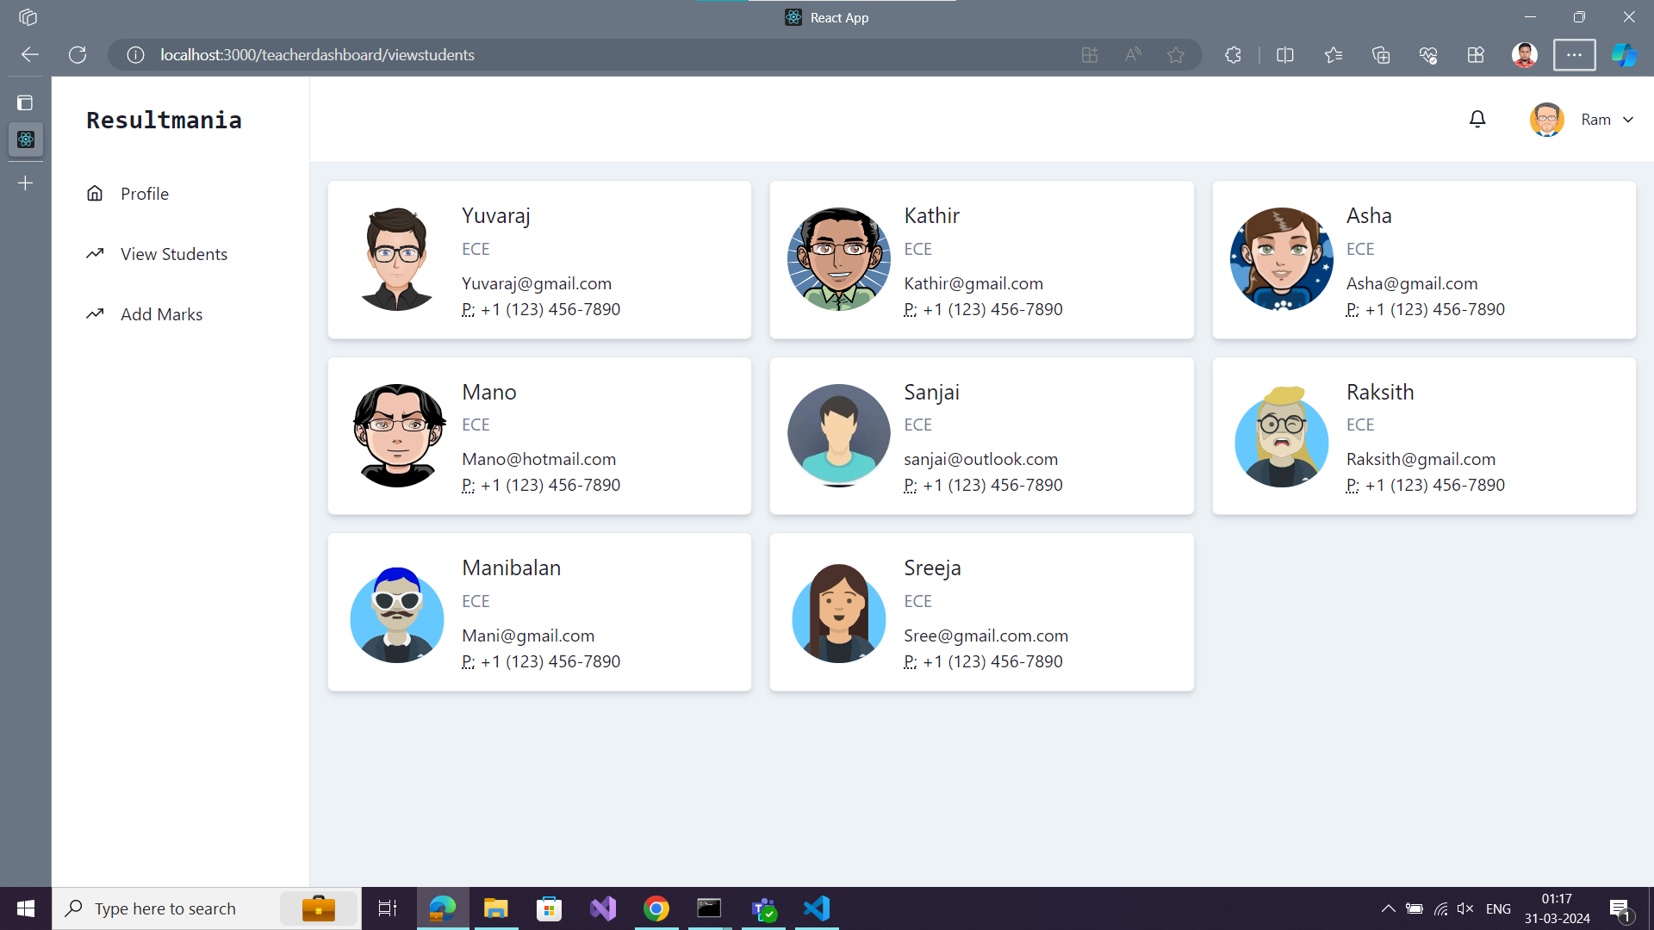

Add marks options:’

Teacher can add marks to students abased on their department and batches :

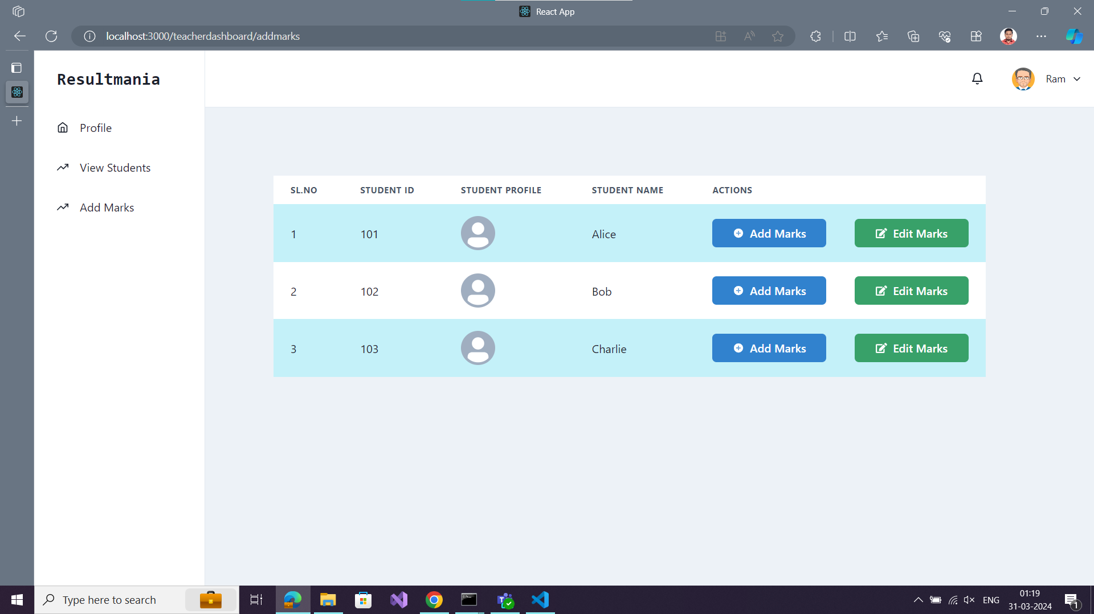

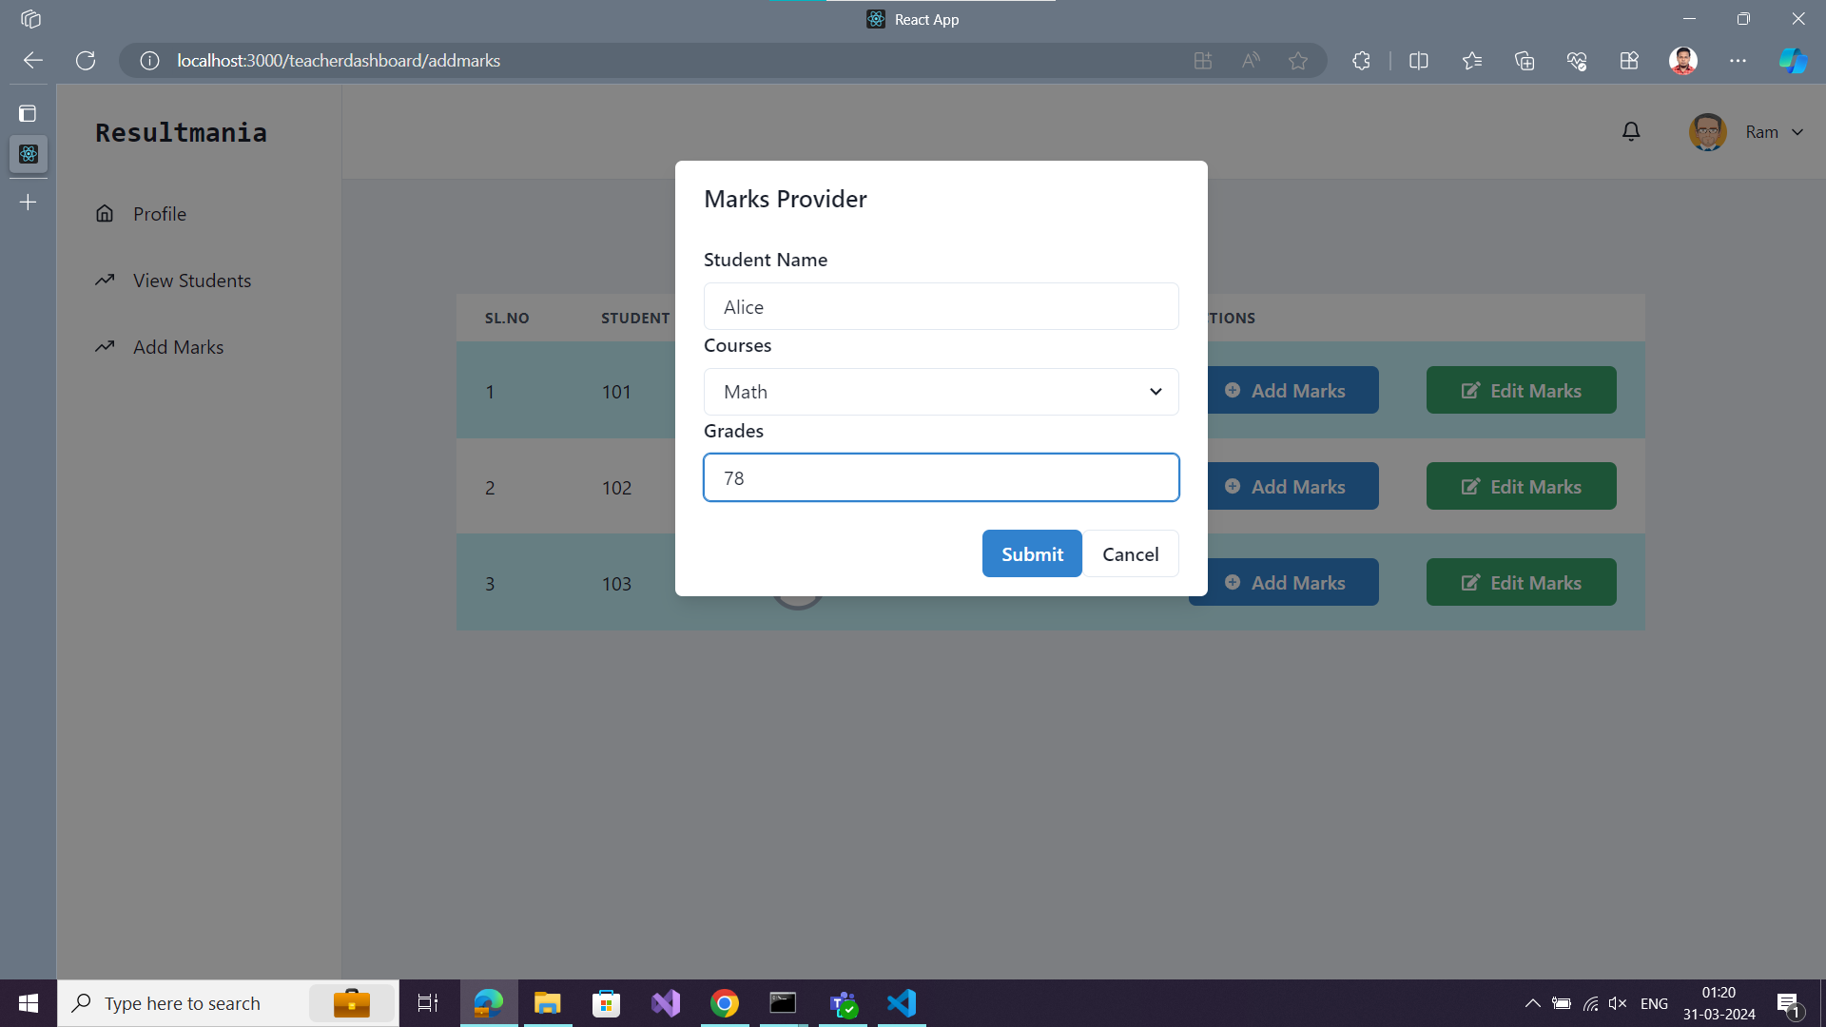

Admin dashboard:

Dashboard page :

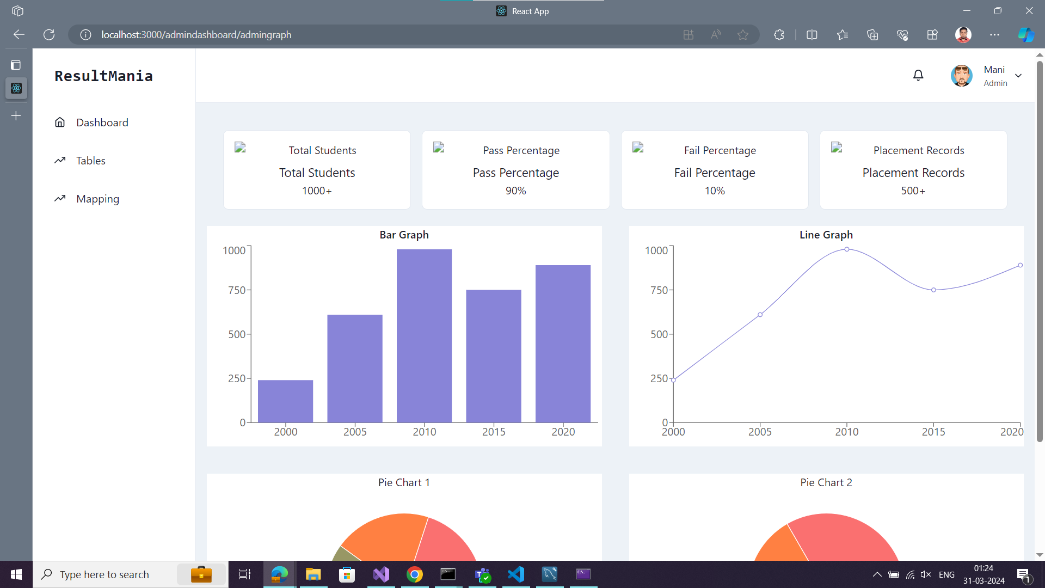

Tables page :

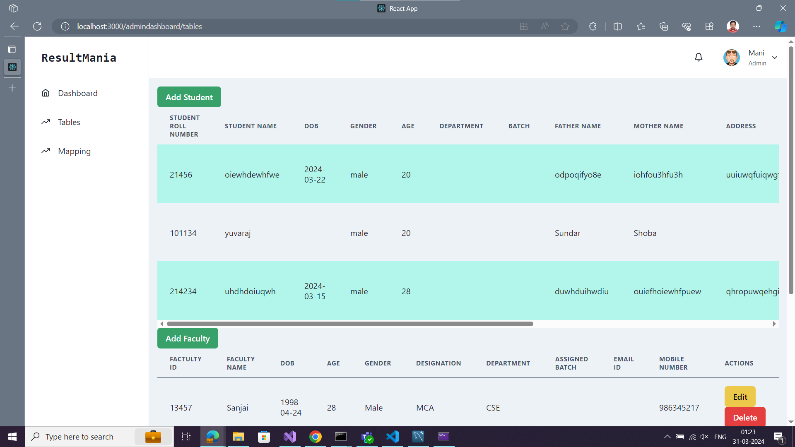

Add student forms:

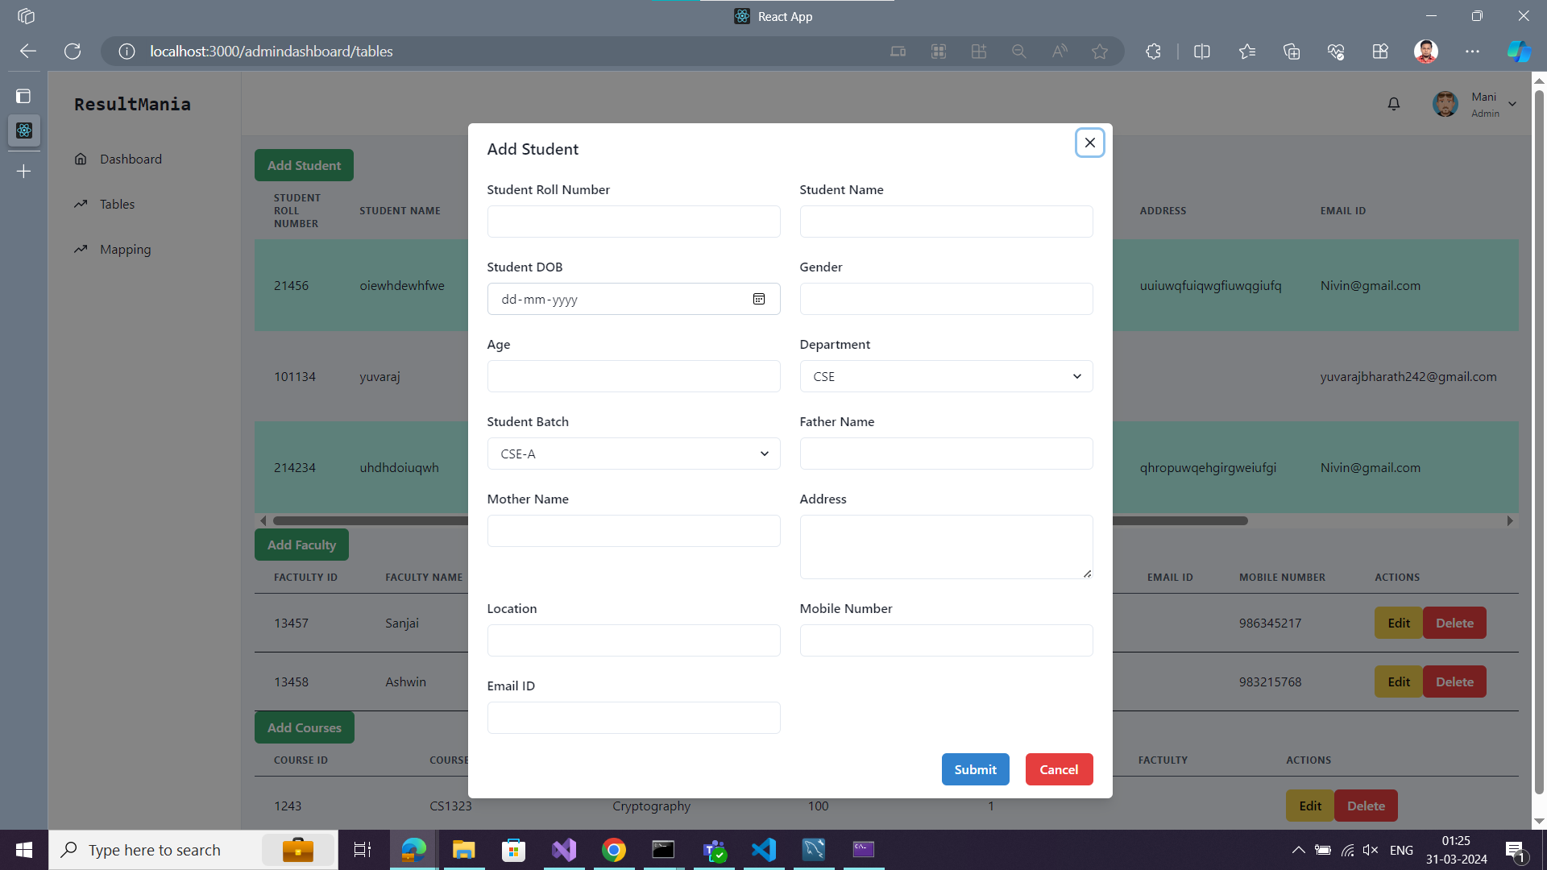

Add teacher forms:

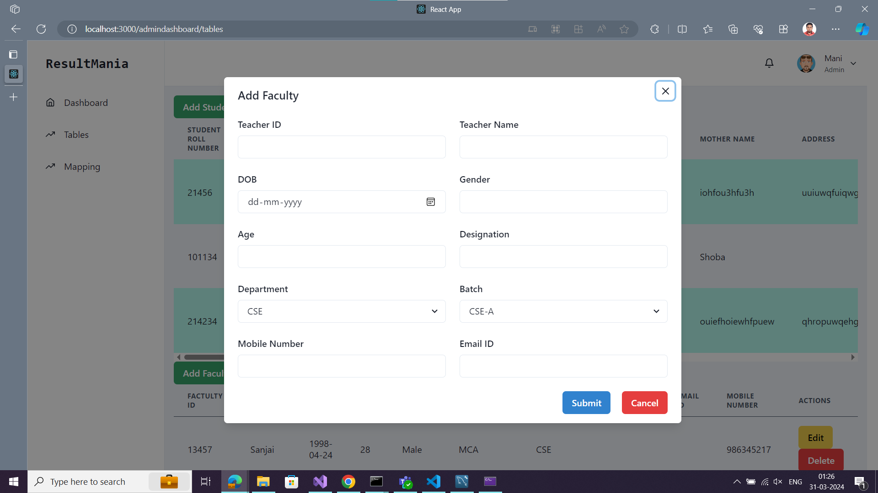

Add Courses:

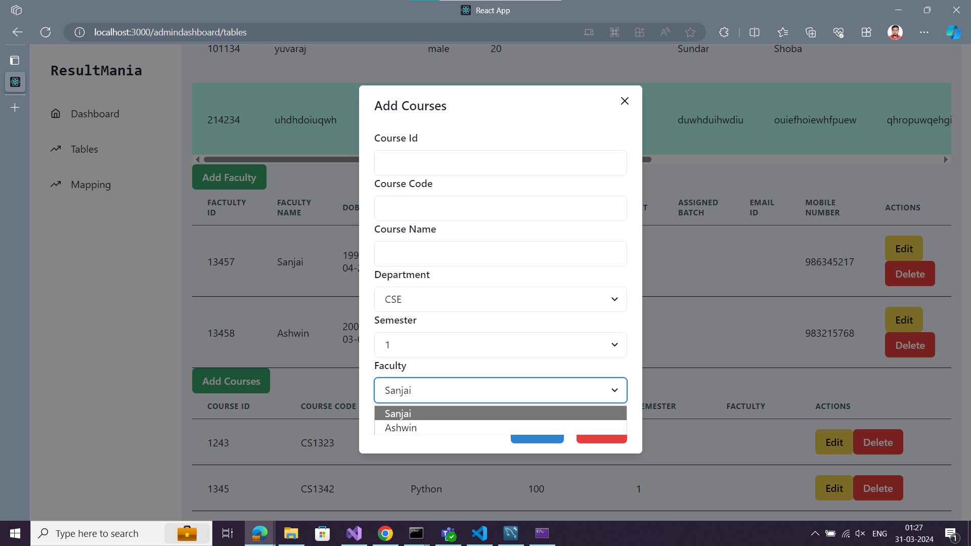That's all abou the frontend

Next is backend :

Swagger api tool output::

